Stevens Institute of Technology
Department of Electrical and Computer Engineering

CpE 646 Pattern Recognition and Classification

Homework 4

Problem 1: Once again we use the data sets “hw3_2_1” and “hw3_2_2” from Homework 3. The sample vectors in “hw3_2_1” are from class ω₁ and sample vectors in “hw3_2_2” are from class ω₂.

Use k-nearest neighbor method to estimate the class conditional density functions p(x|ω₁) and p(x|ω₂) for every x in {-4:0.1:8, -4:0.1:8}; use “mesh” function in Matlab to plot the results; and then classify x=[1,-2]^{t} based on the estimation. Let k=10.

(Hint: The “sort” function in Matlab can be used to find the closest neighbors.)

Problem 2: Now we use the data sets “hw4_2_1” and “hw4_2_2” from file “hw4.mat”. The sample vectors in “hw4_2_1” are from class ω₁ and sample vectors in “hw4_2_2” are from class ω₂. Each of these matrices has a size of 2×100, i.e. 2 rows and 100 columns. Each column is a 2-D observation vector.

2.1 Plot the data set in 2-D use Matlab

2.2 Assume a ϕ function, which projects each input vector 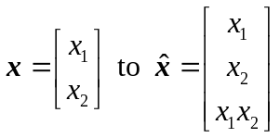, plot in 3-D use Matlab function “plot3”.
2.3 Now define an augmented vector as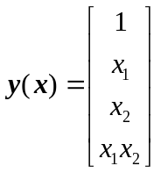. Use the Batch Perceptron method (page 35 and 39, CPE646-9) to find the weight vector 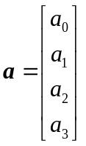 in the generalized linear discriminant function (page 22, 23. CPE646-9).
(Hint: let θ=1, η=1, initialize 

